Fairmilehead Community Council Annual General Meeting (to be followed by Ordinary Meeting), held on Tuesday 2 June 2026 at 7pm, Caiystane Hall, Fairmilehead Parish Church Halls, 1 Frogston Road West, EH10 7AA.

Present: Dennis Williams (Chair); Barbara Dick (Treasurer/Buckstone Association); Stella Thomson (Engagement and Inclusion Officer); Gillian Holmes (Minutes Secretary/Planning Officer); Norrie McLeod (Friends of Swanston Village); Amanda Dovesi; Jamie Adams; Mike Wilson (Editor: The Fairmile, www.thefairmile.substack.com and Build Edinburgh, www.buildedinburgh.substack.com )

Ex Officio: Daniel Johnston MSP (Edinburgh Southern); Councillor Neil Cuthbert (Ward 8)

Craig Moody, Head of Client Relations, Northcare (Scotland) Limited.

Apologies: Ian Murray MP; Councillor Jason Rust; Sergeant Mark Coull; Colin Anderson (Secretary); Janice Pauwels; Helen Wilson; Brian Ralph; Robert Skilling.

8 members of the public.

Welcome
Dennis Williams welcomed all to the meeting and thanked Daniel Johnson MSP and Craig Moody, Head of Client Relations, Northcare (Scotland), Limited for attending. Councillor Cuthbert was thanked for his regular attendance.

Dennis requested that all phones be placed on silent and asked approval from those present to record the meeting. The recording would be used as a time saving experiment to generate minutes using AI and web tools. The recording would be deleted after the transcript has been generated.

The meeting approved the recording.

Declaration of Interests
None were declared.

AGM
Councillor Neil Cuthbert took the Chair for the AGM. He asked attendees to sign the attendance sheet. He noted that The City of Edinburgh Scheme for Community Councils outlines how an AGM should be conducted and that those interested can find details of the Scheme at: www.edinburgh.gov.uk

Minutes from the AGM held on 2 December 2025
Previously approved at meeting held on 3 February 2026.

Reports Submitted for Approval
Report by the Secretary
Approved by the meeting. No questions.
Thanks to Colin Anderson for the time and effort taken to produce both this detailed report and the work he continues to do on behalf of FCC.

Report by the Engagement and Inclusion Officer
Approved by the meeting. No questions.
Thanks to Stella Thomson for both the report and her efforts to expand knowledge of and involvement with the FCC.

Report by the Planning Officer
Approved by the meeting. No questions.
Thanks to Gill Holmes for preparing the report.

Treasurer’s Report
Barbara Dick outlined the report which covered the period 1 April 2025 – 31 March 2026.

Closing Balance £2433.06
Expenditure £1477.30

Main area of expenditure is hall rent.

Current Annual City of Edinburgh Grant is £868.22. Should it remain at this level FCC may face an overspend. Whilst acknowledging the financial constraints facing CEC, community councils require sufficient funding to cover basic organisational costs.

Appointment of Office Bearers

Chair Dennis Williams Proposed: Gill Holmes
Seconded: Stella Thomson

Secretary Colin Anderson Proposed: Jamie Adams
Seconded: Dennis Williams

Treasurer Barbara Dick Proposed: Stella Thomson
Seconded: Dennis Williams

Engagement and Stella Thomson Proposed: Jamie Adams
Inclusion Officer Seconded: Barbara Dick

Dennis Williams resumed the Chair and thanked Councillor Cuthbert for his help. He also thanked Members, attendees, police, MPs, MSPs, and local Councillors for their continued help and support. He noted that FCC had a potentially busy year ahead, especially with regard to the development of the Scottish Water site at Buckstone Terrace.
Dennis invited Daniel Johnston MSP and Craig Moody, Northcare (Scotland), to address the meeting.

Daniel Johnson MSP
Mr Johnson introduced himself and stated that although he was recently elected to the newly redrawn Edinburgh Southern Constituency, he has in fact represented Edinburgh South since 2016. He is committed to working with community councils and seeks active engagement with the community. He views the Scottish Water development as a priority issue within the area. He can be contacted at Daniel.Johnson.msp@parliament.scot .

Craig Moody, Head of Client Relations, Northcare (Scotland) Limited.

Mr Moody thanked FCC for the opportunity to speak and gave a quick overview of Northcare. He advised that Northcare is a family-owned business with 10 care residencies in Scotland, including the recently opened Winton Suites at 5 Winton Drive. Since opening a few months ago, Winton Suites new residents are settling in well and already feel part of the local community. Northcare stage the opening of their new residencies and are to make further rooms available within Winton Suites in the immediate future. Northcare aim to be active in the local communities within which they operate and are keen to address any concerns local residents may have promptly. Information regarding Northcare can be found at: www.northcare.co.uk.

Dennis then moved to the appointment of other FCC positions:

Minute Secretary Position open. Anyone interested please contact the Secretary.

Use of AI being trialled to reduce workload.

Planning Officer Position open. Anyone interested please contact the Secretary. Given the likelihood of future developments within the area, it is essential that this position is filled.

Transport Officer Janice Pauwels Proposed: Dennis Williams

Seconded: Stella Thomson

Representative on the Colin Anderson Proposed: Jamie Adams

Edinburgh Association Seconded: Dennis Williams

Of Community Councils

(EACC)

Representative on Funding

Panels:

Pentlands Jamie Adams Proposed: Dennis Williams Seconded: Stella Thomson

Morningside Stella Thomson Proposed: Gill Holmes

Seconded: Dennis Williams

Representative on Amanda Dovesi Proposed: Dennis Williams

The Pentland Hills Seconded: Gill Holmes

Regional Park

Consultative

Forum

Frequency of Meetings

Resolved that in accordance with the CEC Scheme for Community Councils, FCC will meet on

the first Tuesday of the month for the remainder of 2026 (with the exception of July and August), and for the first half of 2027 (with the exception of January) at 7pm in person within the Caiystane Hall, Fairmilehead Parish Church, 1 Frogston Road West, EH10 7AA.

THIS CONCLUDED THE AGM

FCC ORDINARY MEETING

Minute of Meeting held on Tuesday 5 May 2026

Approved by the meeting.

Matters Arising

Road Repairs

Councillor Savage had followed up on a question raised regarding the composition and durability of the asphalt used for temporary repairs. He received this reply from the Transport Team:

“For our resurfacing schemes we use either 55/10 or 55/14 - Hot Rolled Asphalt surface course.

For temporary repairs, we use cold tar, which doesn’t last as long, as it just a temporary measure.”

Frogston Avenue ( adjacent to the Church)
Repairs were carried out last week by patching some of the worst potholes. This follows the “reactive inspection” carried out in February 2026.

The following comments were received from residents:

- “The general view from neighbours in the local WhatsApp group is that they have done a terrible job, and it is not expected to last very long at all.

I am no expert, and it is certainly better than it was, but it is still a bit bumpy to drive over. I think nobody expects the repairs to last because it is such a large patchwork job, some of the potholes are a bit rough round the edges, and I can believe that the repairs will start to crumble in time. I suppose time will tell. I think the damage to the road surface was so extensive that it would have made more sense to do a complete resurfacing of the road. Just the bit outside the Church of course”
- “It would seem the local forums are up in arms about the patchwork quilt quality.

Must confess doesn’t look great but hopefully will perform. Gut reaction next few years it will need to be resurfaced since no doubt the repairs will struggle during the winter months”

Colin passed these comments to Councillor Rust who forwarded them to the Transport Team.

Councillor Cuthbert reported almost £240,000 had been spent on road repairs in Ward 8 in the 2025/26 period. Ward 6, Corstorphine/Murrayfield had the highest level of road spending.

Dropped Crossings at 68/72 Pentland Terrace

Residents had complained when a channel was installed which made crossing more difficult. Responding to these complaints, the channels have been removed and the area resurfaced.

Biggar Road

A section of Biggar Road, opposite the Convenience Store, had been highlighted as being in a dreadful condition. Council have stated that it currently does not merit repair but that it will be monitored.

Councillor Cuthbert emphasised that when reporting a repair/complaint it is essential to get a reference number. Equipped with a reference number, Councillors can then follow up on it.

Lothianburn Junction

Significant back up of traffic from Fairmilehead Crossroads, through Lothianburn to new traffic signals at Hillend is now a frequent occurrence. Recently an ambulance struggled to make its way through and had to use the opposing carriageway.

Councillor Cuthbert highlighted the problem of the complex responsibilities for the road across CEC, Transport Scotland and Midlothian Council. Councillor Cuthbert has written to the Transport Secretary, Stephen Flynn MSP, who has raised the issue in the Scottish Parliament. A response is awaited from the Scottish Government.

Daniel Johnson MSP thought reverting to previous road arrangements was unlikely but that pressure to improve the situation must be maintained. He said that the current situation is unacceptable.

Councillor Cuthbert said that Transport Scotland statistics have revealed that Lothianburn is the busiest non-motorway junction in Scotland.

The suggestion was made to collect photographic evidence of congestion to forward to Transport Scotland. It was also proposed to invite a Transport Scotland representative for an on-site visit to witness the issues.

Community Speed Watch Programme

Sergeant Coull has previously sought volunteers from the FCC area to join the Community Speed Watch Programme detailed below. Should no volunteers be forthcoming the Sergeant will ask another Community Council.

(As a reminder, here is a recap on what is involved - A local Police single point of contact will be allocated. 3-5 volunteers required, 3 of whom must be present when carrying out the speed checks. One is required to note the details and the other two for observations and corroboration. Vetting – all those taking part must first be vetted by the Police and this takes 12-14 weeks. The Community Council will suggest roads they would like to target and the Police will carry out a health and safety assessment to check suitability. Roads should only be 20, 30 or 40mph zones, so not the Bypass!!! Must also be done in the daylight and not incremental weather such as thick fog, for example. Two signs also required for the grass verge, pavement that say Community Speedwatch. Public Liability Insurance is required. Details of vehicles and speeds to be logged on a preprinted form and then sent to the Police contact. Police will then carry out checks to obtain the keeper details for the vehicle and send a warning letter. A third letter will be hand delivered to the Police with an educational chat about their speed. Those taking part have no Police powers to stop vehicles or speak to drivers. Their duties are simply to log details of vehicles and their speed. Training will be given to all taking part and this should take 2-3 hours. This will include how to use the speed gun, how to log the paperwork and deescalation tactics should any confrontations occur. The expectation is this would be done say two or three times a month – not every day!)

Correspondence and Report from the Secretary
The Fairmile
Now has 377 subscribers.

Community Grants Fund
Grants of up to £5000 can be awarded to constituted groups for activities which benefit the local community. The application deadline is 29 June 2026. It is believed there will only be one round of funding this year.

Council Consultation on Public Entertainment Licenses
CEC currently has a consultation on entertainment related licences (food, drink etc). The public response deadline is 4 August 2026 with a Council review meeting expected 29 September 2026. The consultation can be found at:
Public Entertainment Resolution and Licence Conditions- 2026
www.consultationhub.edinburgh.gov.uk

Financial Report
Covered as part of the AGM.

Scottish Water Office Development, Buckstone Terrace
Post the public consultations (Ref; 26/00798/PAN), no further information has been received. It is expected that Planning Permission in Principle (PPiP) will be lodged June/July 2026. Councillor Rust has asked Scottish Water for an update.

FCC will be seeking “Statutory Consultee Status” on the PPiP application and there may be a Special Meeting of the FCC to discuss the application.

Mike Wilson had been advised by the Scottish Water Property Manager that there had been 160-180 responses following the public exhibitions. How these responses may influence the design of the PPiP is uncertain.

Local Place Plan (LPP)
The Sub-committee continues to work towards the preparation of a LPP for consideration in the preparation of CEC City Plan 2040.

To gain further views and ideas from all within the community, a survey for completion by pupils will be sent to some local schools before the completion of the summer term.

Some FCC members had a productive meeting with major local landowners, Alistair McClung, Swanston Farm Ltd, and Henry Trotter, Mortonhall Estate. Both are keen to ensure on-going public access to their land, wish to be involved with the local community and neither have plans for any large-scale building schemes. Henry Trotter raised concerns about the fitness of current conservation regulations particularly as they apply to dilapidated buildings. Both will be sent advance copies of the LPP.

Planning Matters
Conversion of the former Charwood Restaurant – Ref 26/01377/FUL
Documents continue to be lodged including a revised site plan, roof plan, kitchen ventilation details and a ventilation and acoustic information sheet.

5 objections were lodged on the planning portal. Councillor Cuthbert said he had been contacted by residents concerned about the knock-on effects on parking within the immediate area.

UPDATE: Application approved 17 June 2026 – conversion work underway.

Car park signage at the former Charwood Restaurant – Ref 26/01740/ADV
Original application was for 4 signs with “Miller & Carter Steakhouse” branding. Revised to 2 signs on 15 May 2026.

Application was approved on 27 May 2026

Braid Hills Care Home, Liberton Drive Ref 26/02266/PAN

Crown Care has submitted a PAN for the replacement of the existing 119 bed Braid Hills Nursing Home with a new 132 bed nursing home and associated retirement/specialised care.

Public Events to be held within the existing building on:
Wednesday 8 July 2026 3.00 pm - 7.00pm
Wednesday 5 August 2026 3.00pm - 7.00pm

The previous Nursing Home was operated by BUPA and closed in July 2024.

Craig Moody was surprised by the size of the proposed development. Recent changes do allow for larger bedded properties, but even allowing for this, the scale would represent a different type of facility to past care homes.

Proposed office and staff accommodation with underground parking at land 20 metres north of 106A Biggar Road – Reef 26/01575/FUL
Lodged last month by Swanston Farm. The site is adjacent to the side entrance of what was the Lothianburn Golf Clubhouse.

UPDATE: application withdrawn 17 June 2026

Davidson House, Salvation Army Care Home, Colinton – Ref 26/01127/FUL
In response to a question regarding the site, it was confirmed that following the closure of the facility the structure was demolished. Subsequently an application for planning permission to build a replacement 50-bed care home was lodged.

This application was refused on 16 June 2026.

Transport and Environment
Drainage Works Winton Drive
Now completed.

Pavement Resurfacing Winton Drive
Craig Moody is to meet with a Transport Officer to discuss pavement resurfacing around the area of the Winton Suites.

UPDATE: the following was received from Councillor Rust:

“Following recent site visits and inspections the road surfacing programme has been extended to cover most of the track where the drainage works took place in April - so there will be a new surface from Frogston Road West to Winton Gardens. These surfacing works are scheduled for 15th July 2026.

On 15th June 2026 (one day) there will be patching works in preparation for the surfacing works on 15th July.

Between 16th June & 15th July – drop kerbs & footpath surfacing work will take place.

Below is a marked up plan showing the agreed area on footpaths that will be resurfaced by the care home contractor.

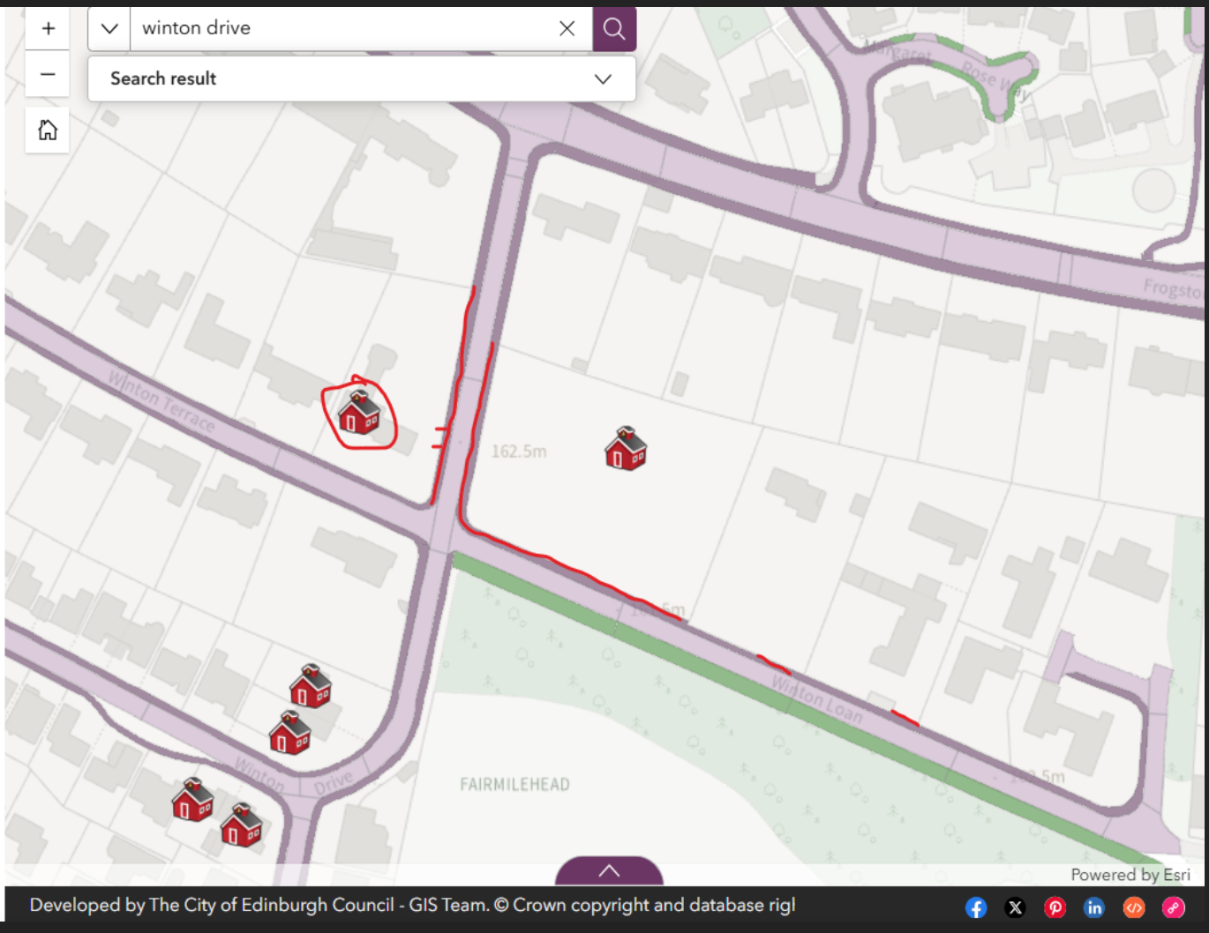footpath surfacing work will take place.

I appreciate more disturbance, but I wanted to provide you with advance notice and ideally by the end of next month we will have visibly better road and pavements in the area. showing the agreed area on footpaths that will be resurfaced by the care home contractor.”

Braid Estate ETRO – Greenbank to Meadows quiet route
Covid era measures which are the subject of an ETRO due to expire on 15 June 2026, were found to have paperwork errors meaning that they could not be confirmed as permanent at a meeting of the TRO sub-committee on 12 May 2026. Consequently, a report was prepared for the Transport and Environment Committee on 18 June 2026. At this meeting the committee agreed by six votes to five to accept officers’ recommendations to take out two modal filters and carry out traffic monitoring before any new measures are introduced.

Bus Gate Morningside Road
Bus gate on Morningside Road suggested elsewhere. Opposition to idea due to it being a main route.

Transport Scotland Planned Works for 2026
Published plans include A720 bypass and A702 section closures. Details to be found on the Bear Scotland website at: www.bearscotland.com . Follow links under “News”.

Reports from Councillors
ETRO process
With regard to the whole process of producing a TRO (traffic regulation order) or ETRO
(experimental traffic regulation order), Councillor Cuthbert said the public are confused. Meetings of both the Transport Committee and TRO Subcommittee often end without clear summaries. Verbal floor amendments add to the confusion. Mike Wilson said that at the end of the Subcommittee meeting in May it was unclear what had been decided. He had asked the Council press office for clarification but even they were not entirely sure.
Councillor Cuthbert added that work is on-going to streamline council business to provide improved clarity and facilitate public understanding. Major change is unlikely until after the 2027 Council elections.

He will pass comments re confusion to Council Officers.

In response to a question Councillor Cuthbert clarified that:
An Amendment – changes a motion
An Addendum – adds to a motion

Cycle Route development by Midlothian Council
Councillor Cuthbert said he had heard through a third-party source that Midlothian Council are developing a cycle route to include Hillend and Swanston. Councillor Cuthbert had asked Midlothian if FCC could be provided with details but was advised that at the moment it was deemed “sensitive information”. Council Officers wish to avoid raising premature expectations, but it is their intention to share documents once permitted. Route considerations would include congestion at Hillend/Lothianburn, preference for off-road paths to avoid bypass choke points, provision of safe connections for students at the Bush.

Community Council Communications Role and Locality Model

Councillor Cuthbert advised that a role as CEC Communications and Engagement Officer for Community Councils is expected to be advertised soon. Hopefully a positive step in strengthening the links between Council and Community Councils.

He also advised that there has been a proposal to reintroduce a locality based structure (e.g., Edinburgh Southern) for targeted services like roads. Given the diverse nature of Edinburgh’s often distinct areas this could be a sensible approach.

AOCB
Responsibilities of Councillors vs MSPs
In response to a question, Councillor Cuthbert acknowledged that residents are often unsure of “who deals with what”. However, irrespective of the issue whoever is contacted will direct people to the appropriate source.

Councillor Cuthbert and Daniel Johnson MSP felt that as a general rule it could be seen as:
- MSP/Scottish Government: health, police, intercity transport, broader policy, agriculture, enterprise, overarching education policy.
- Council: local roads/transport, social services, community support, running schools, leisure, most daily services.

Roughly 80% of public services are Council funded whilst Council funding is roughly 25% of the Parliamentary budget. MSP’s and Councillors often collaborate effectively across parties.

State of Edinburgh City Centre
Concerns were raised regarding the poor state of repair of pavements on Princes Street, a tourist having been witnessed falling and requiring an ambulance. Homelessness is also highly visible on Princess Street and near Waverley Court. Councillor Cuthbert said pavement damage in the centre is exacerbated by van deliveries which are permitted on the pavements during set delivery times. Heavier buses are causing additional damage to both roads and pavements, especially near bus stops, although additional funds exist for bus stop repairs. With regard to homelessness, Councillor Cuthbert said in the midst of a citywide housing emergency the Council is working hard to alleviate the situation. Efforts include a push to build more homes and increase social housing through private developers. Future improvements depend heavily on Scottish government funding.

Braidburn Valley Park
Annual Duck Race
Last weekend in August. Check website for details: www.braidburnvalleypark.org.uk

Brass at Braidburn
Edinburgh Brass Band (a community brass band) to perform on Saturday 1 August 1pm-3pm. First concert in the park in roughly 80 years.

Departing FCC Member.
Thanks to Gill Holmes who leaves the FCC due to grandparent duties.

Date of next meeting
Tuesday 1 September 2026.

NB – In the event of a PPiP for the Scottish Water site being submitted, a Special Meeting of the FCC may be arranged before September. 10 days’ notice will be given.

